DialogEduShift: Transforming Higher Education Teaching and Evaluation Approaches in the Era of AI Chat Tools
National Multiplier Event
Host: online, June, 30
Country: Ukraine

Overview of the Multiplier Event
The Ukrainian Multiplier Event was held online on June 30, 2025, from 15:00 to 18:00 Kyiv time. The event gathered 32 participants representing academic and management staff from Sumy State University. Promotion was carried out via the E-cabinet of Sumy State University, targeted faculty email lists, and professional networking platforms such as LinkedIn.
The event was framed as “Generative Artificial Intelligence Day”, serving as a platform to present and disseminate the project results of DialogEduShift. The sessions were facilitated by Yuriy Zuban, Director of the Center for E-Learning Technologies, and Svitlana Tarasenko, As.Professor at the Department of International Economic Relations. Both presented the project’s intellectual outputs, including:
- Manual for HEIs on the Use of Artificial Intelligence
- Guidelines for Academicians on the Usage of AI Conversational Bots (LLM Models) in HEI
- The possibilities of digital avatars for teachers
- Online course for teachers “The Usage of AI Chat Tools in Higher Education”
- Video product.
The event was considered a success. Participants actively engaged in the discussion session, sharing concerns about ethical use of AI, evaluation of AI-generated assignments, and the risks of plagiarism. Key challenges such as limited awareness of AI’s potential and uneven levels of digital readiness were overcome through demonstrations of project outputs and practical cases.
The benefits to participants included access to structured guidelines and teaching resources, enhanced awareness of AI’s opportunities and risks. The event’s impact is visible in the increased commitment of participants to pilot AI-based practices within their institutions and to disseminate the project results among their colleagues.

Profile of Attendees
The Multiplier Event gathered 32 participants: 17 women and 15 men, representing both academicians and management staff of university. The participants’ age group ranged mainly from 30 to 55 years, with professional backgrounds in economics, philology, computer science, pedagogy, and education management.

This profile directly corresponds to the project’s target group: higher education teachers and administrators responsible for implementing innovative teaching and evaluation methods.

Agenda for the Event
Ensure you include all Project Results in the agenda as this is required by the National Agency.
Timing | Agenda Item
15.00-15.10 | Introduction
15.10-16.20 | Presentation WP2, WP3, WP4
16.20-17.20 | Discussion, feedback
17.20-18.00 | Open questions, next steps of AI integration at SSU

The agenda ensured that all Project Results were presented and discussed.
Overview of Feedback from Attendees

Feedback was collected through oral contributions during the discussion and via online survey distributed during the event in Zoom tool. Participants noted that the Guidelines and Manual offered much-needed clarity on ethical aspects of AI use and provided practical steps for classroom integration. Many expressed interest in the online course as a tool for professional development.
Survey results indicated that:
- 88% found the event highly relevant to their professional activities
- 85% considered the project results as directly applicable within their institutions.
Overall, the Multiplier Event achieved its goals: it strengthened awareness, disseminated project outputs to a broader academic audience.

Screenshots of the Promotion of the Event
E-cabinet SSU, LinkedIn
https://www.linkedin.com/posts/%D1%81%D0%B2%D1%96%D1%82%D0%BB%D0%B0%D0%BD%D0%B0-%D1%82%D0%B0%D1%80%D0%B0%D1%81%D0%B5%D0%BD%D0%BA%D0%BE-b11779150_%D0%B2%D0%B5%D0%B1%D1%96%D0%BD%D0%B0%D1%80-%D0%B4%D0%B5%D0%BD%D1%8C-%D0%B3%D0%B5%D0%BD%D0%B5%D1%80%D0%B0%D1%82%D0%B8%D0%B2%D0%BD%D0%BE%D0%B3%D0%BE-%D1%88%D1%96-3006-1500-activity-7341405585923321857-pEg0?utm_source=social_share_send&utm_medium=member_desktop_web&rcm=ACoAACRrzf0BeObmkczBGDsrSSNL9jPCrHqPH_Y

Photographs of the Multiplier Event
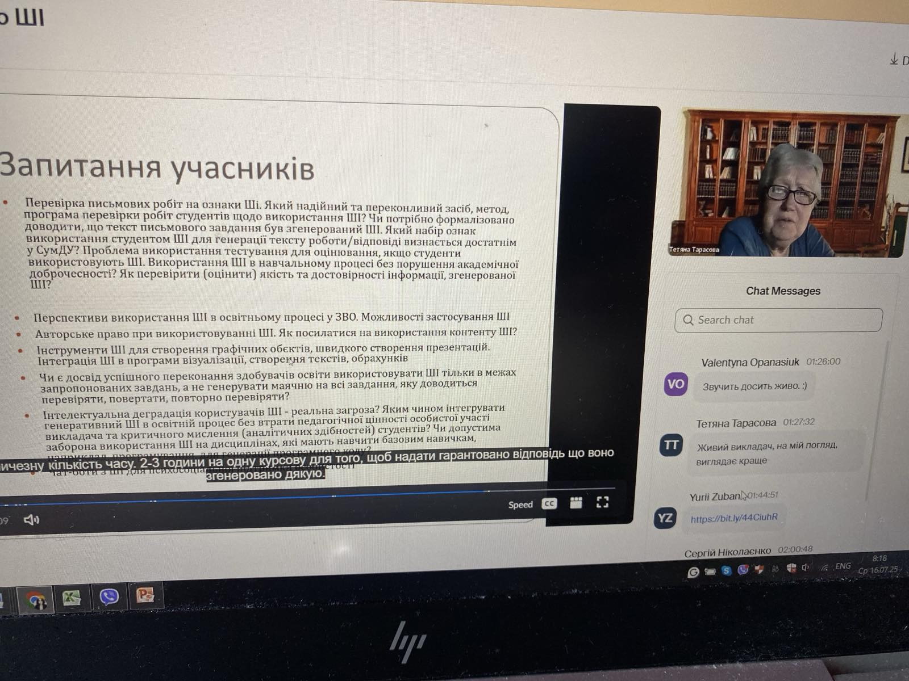
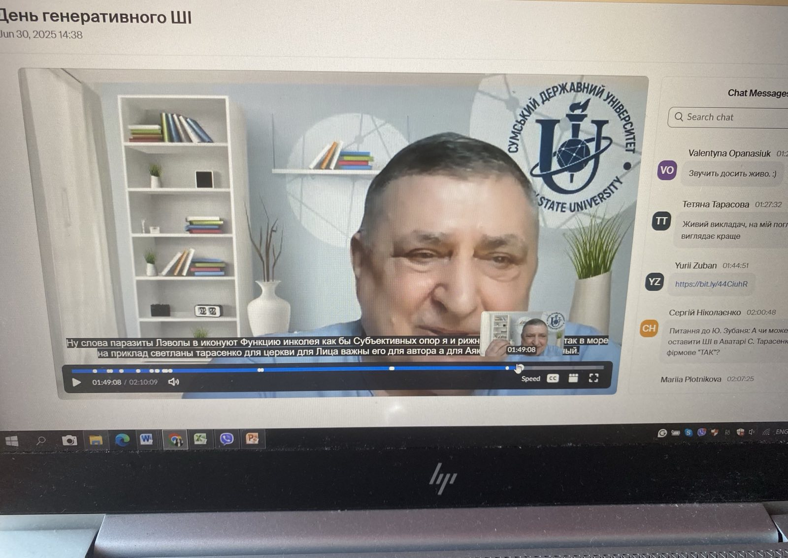

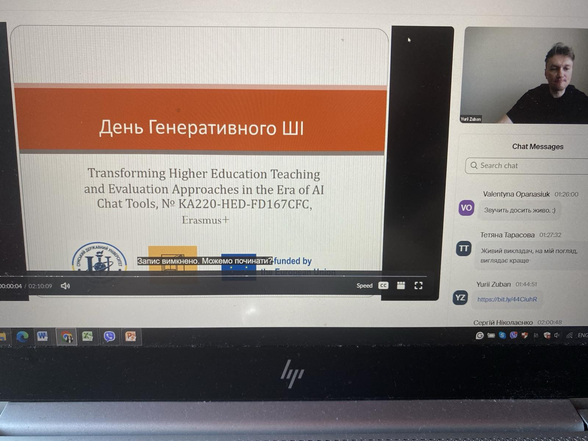

Multiplier Event Evaluation Survey

Thank you for attending our DialogEduShift event. Your feedback is crucial in helping us improve future events. Please take a moment to respond to the following statements by selecting the answer that best reflects your experience.

 | Strongly Disagree | Disagree | Neutral | Agree | Strongly Agree
 | 1 | 2 | 3 | 4 | 5
- The event met my expectations in terms of content and delivery

- The speakers and facilitators were knowledgeable and engaging.

- The topics covered in the event were relevant to my professional or personal interests.

- I feel more informed about the topics and themes of the DialogEduShift project after attending the event.

- The event provided valuable networking opportunities with other participants.

- I would recommend the DialogEduShift resources to my colleagues or peers.

Google Links to Survey
- Germany - https://forms.gle/S5du9mqecRcy4wdx7
- Turkey - https://forms.gle/A1NcnG5paTDMjPgu8
- Ukraine - https://forms.gle/WKMyENMs9oWrNbmG9
- Latvia- https://forms.gle/JKh1Yw2bTTEbvaDX9
- Poland - https://forms.gle/VTHeqtBttG56MbxC7

