DialogEduShift: Transforming Higher Education Teaching and Evaluation Approaches in the Era of AI Chat Tools
Project no. 2023-1-PL01-KA220-HED-000167212
National Multiplier Event
Host: RTU Rezekne Academy
Country: Latvia

Overview of the Multiplier Event
The Multiplier Event took place on 5 June 2025 from 13:30 to 16:30 at RTU Rezekne Academy, Atbrivosanas aleja 115, Rezekne, Latvia. A total of 42 participants attended the event.
To promote the event, the RTU Rezekne Academy employee email system was used to send out invitations and an informative message about the project and the registration process. Additionally, a poster inviting participants to join the event was displayed at the RTU Rezekne Academy IT Centre. Thanks to these efforts, 42 participants joined the event.
The event began with a welcome address by Prof. Dr. paed. Jānis Dzerviniks, Acting Head of the Centre for Education, Languages and Social Technologies at RTU Rezekne Academy. In his remarks, he highlighted the importance of innovation and digital tools in the academic environment, as well as the relevance of the project to the institution’s strategic development.
During the event, participants were introduced to the results of the project, with special focus on the developed course materials and their application in higher education. The session was designed to be interactive, allowing participants to explore the course modules on computers in real time.
The chosen computer room was slightly limited in space for the group, but it was important to ensure that participants had access to a computer to fully explore the project materials. Participants appreciated the opportunity to explore practical resources, gain insights into innovative teaching strategies, and exchange ideas with colleagues. The event helped raise awareness of the project and its results and sparked interest in further integration of AI-enhanced tools into teaching practices.

Profile of Attendees
The attendees of the multiplier event represented three main groups: academic staff (29 participants), administrative representatives (3 participants), and students (10 participants). The average age of the participants was 43.62 years, with the youngest being 20 and the oldest 69 years old. The gender distribution was balanced, reflecting the diverse academic community of RTU Rezekne Academy.
Participants came from a range of academic and professional backgrounds, including engineering, information technology, education sciences, law, translation, library science, and philology. This multidisciplinary representation ensured a rich and varied discussion during the event, with insights contributed from both theoretical and practical perspectives.
All attendees were directly relevant to the project’s target group, which focuses on academic staff and higher education stakeholders involved in the development and implementation of innovative, AI-enhanced educational practices. The inclusion of students also provided valuable end-user perspectives, supporting the project’s goal of fostering inclusive and future-oriented higher education environments.

Agenda for the Event
Timing | Agenda Item
13:30 – 14:00 | Registration and coffee
14:00 – 14:15 | Opening address and agenda overview – Aleksejs Zorins, Project Coordinator
14:15 – 14:25 | Welcome address by Prof. Dr. paed. Jānis Dzerviniks, Acting Head of the Centre for Education, Languages and Social Technologies, RTU Rezekne Academy
14:25 – 14:45 | WP2 results: Handbook for HEIs (Anda Āboliņa)
14:45 – 15:05 | WP3 results: Guidelines on the Use of AI Chat Tools in Higher Education (Aleksejs Zorins)
15:05 – 15:25 | WP4 results: Course for Academic Educators (Anda Āboliņa)
15:25 – 15:55 | Coffee break and informal conversations
15:55 – 16:15 | Discussion
16:15 – 16:30 | Conclusion

Overview of Feedback from Attendees
The feedback collected from the Multiplier Event participants was positive. Most attendees expressed satisfaction with the event content, delivery, and relevance to their professional interests.
According to the survey results:
- 85,7% of respondents agreed or strongly agreed that the event met their expectations in terms of content and delivery.
- 85,7% found the speakers knowledgeable and engaging.
- 88,1% considered the topics covered to be relevant to their professional or personal interests.
- 85,7% felt more informed about the DialogEduShift project after the event.
- 98,1% agreed that the event provided valuable networking opportunities.
- 95,7% indicated they would recommend the DialogEduShift resources to colleagues or peers.
The event was perceived as well-organized and professionally delivered. Participants thanked the organizers and project team for their efforts, indicating that the content would be useful in their future academic or professional work.
Many appreciated the ethical dimension of the discussions, while others expressed interest in more practical materials and a desire for similar events in the future, particularly those focused on AI in education.

These results show that the Multiplier Event was successful in engaging the target audience, raising awareness of the project’s goals, and stimulating interest in the integration of AI-enhanced tools in higher education. The feedback also highlights a growing need for follow-up activities and practical support materials tailored to academic staff.

Screenshots of the Promotion of the Event
On May 27, an invitation email was sent to rta.darbinieki@rta.lv (228 RTU Rezekne Academy employees).
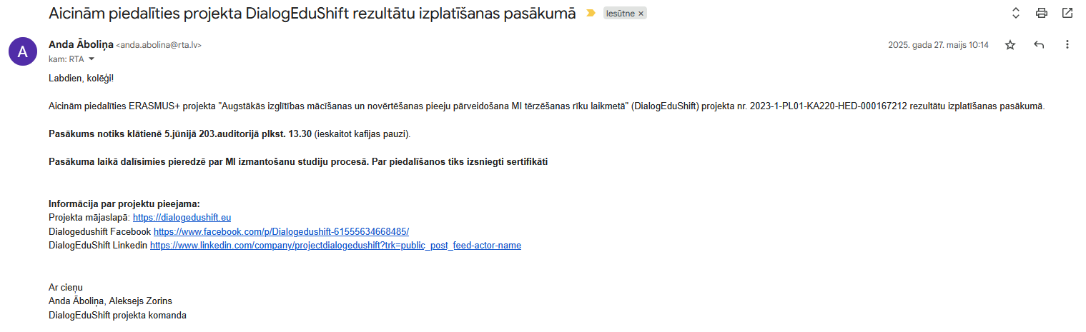
Attached poster in Latvian.
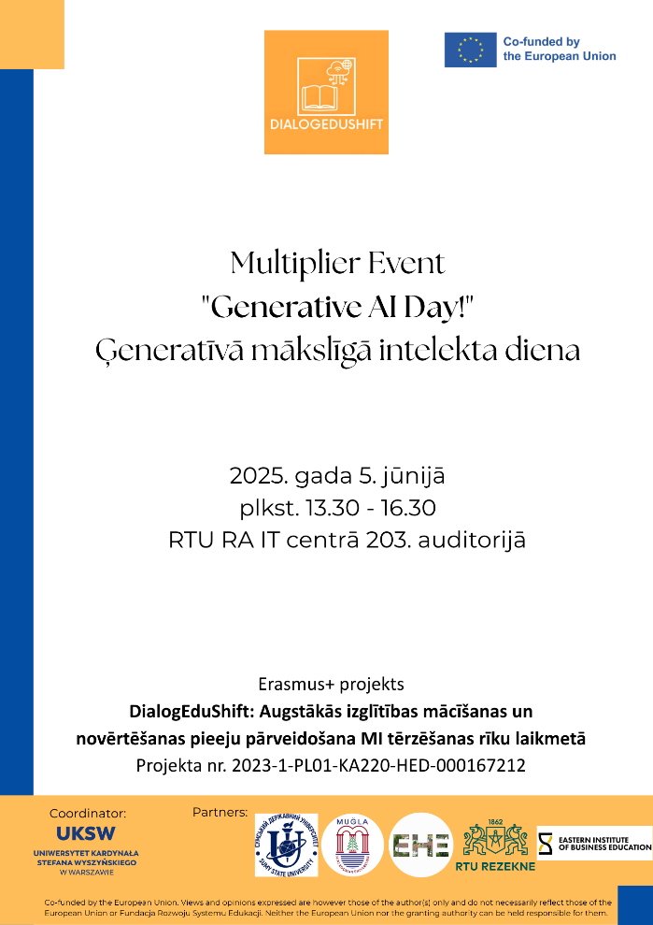

Photographs of the Multiplier Event
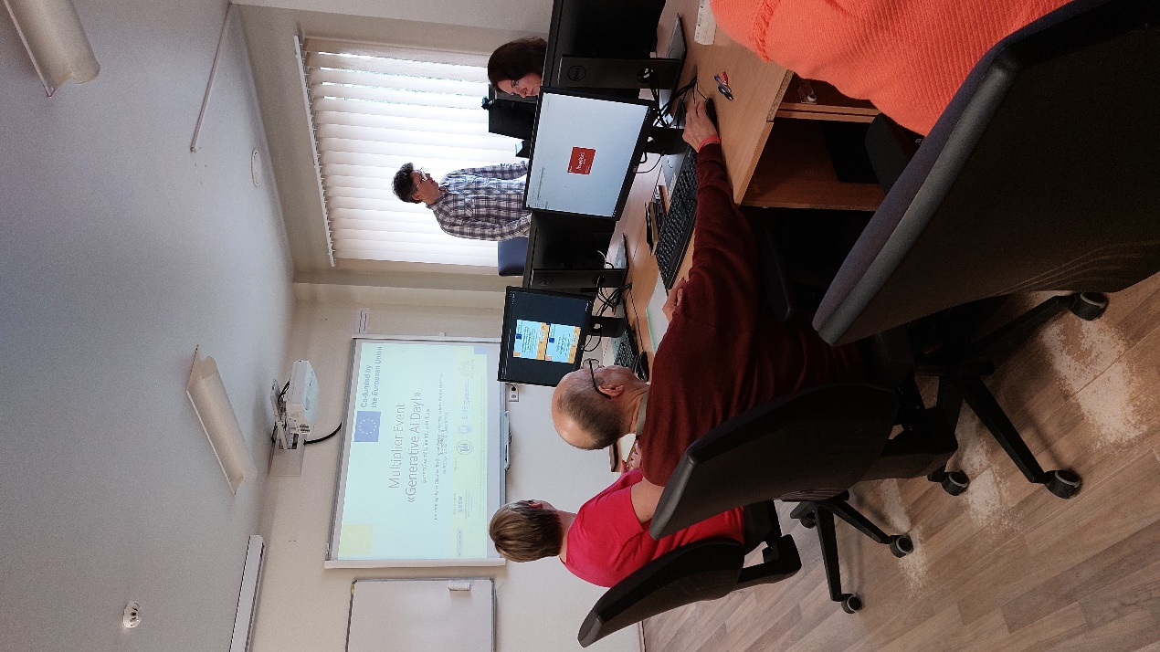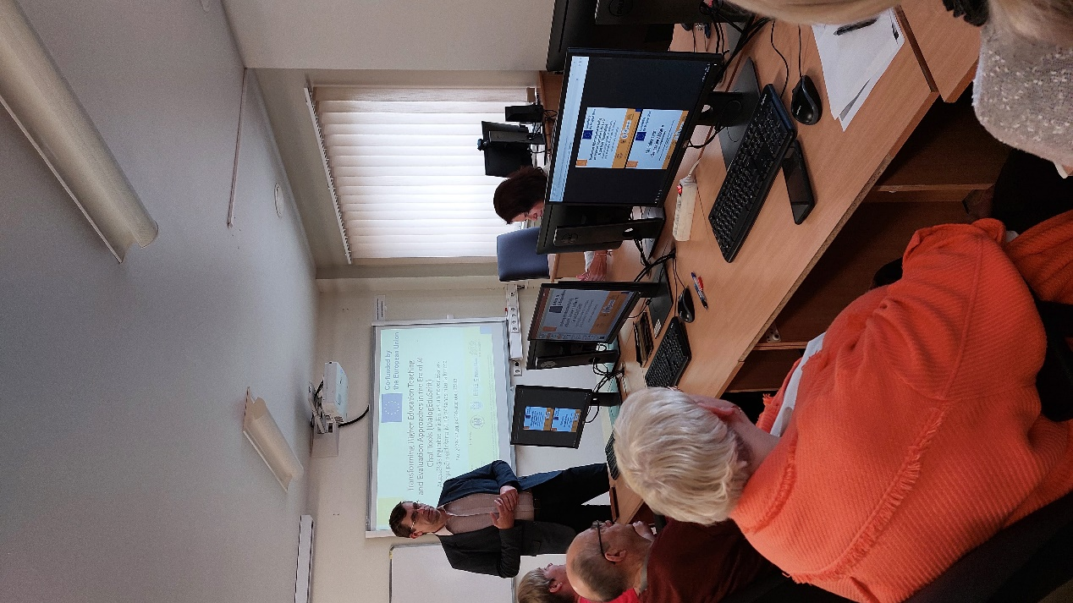

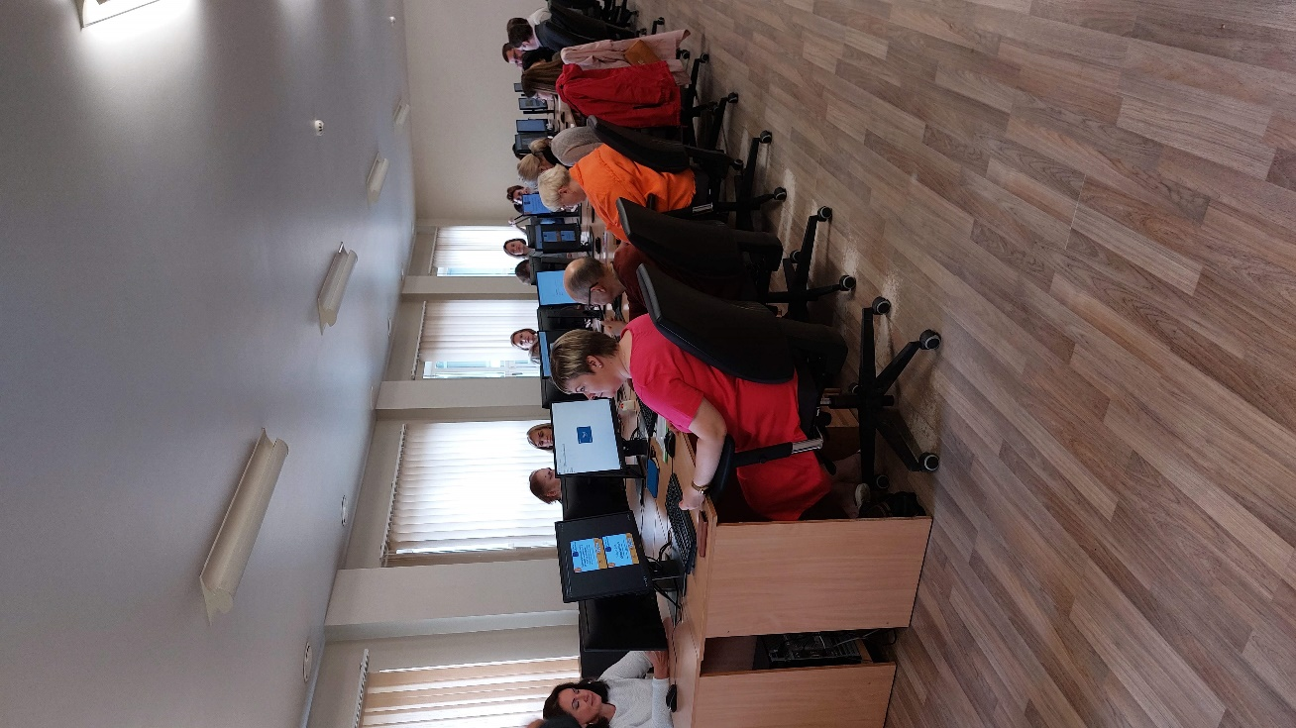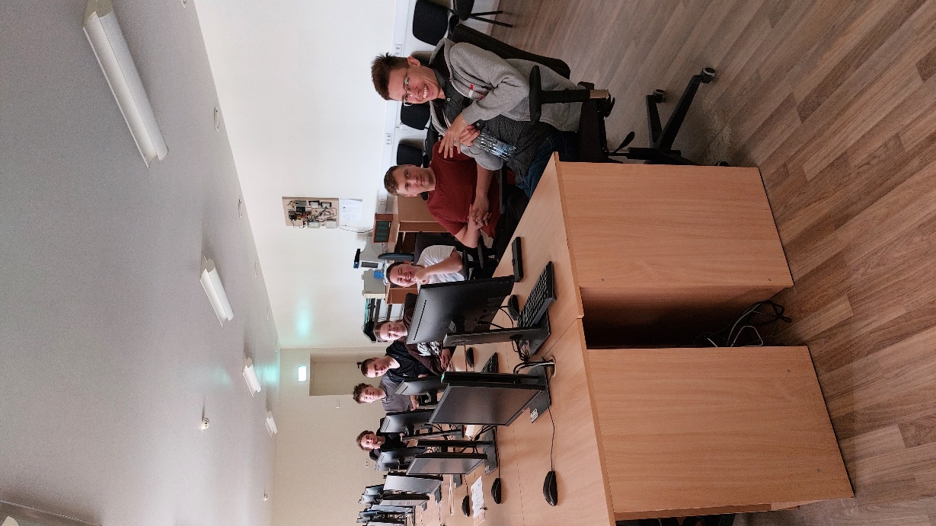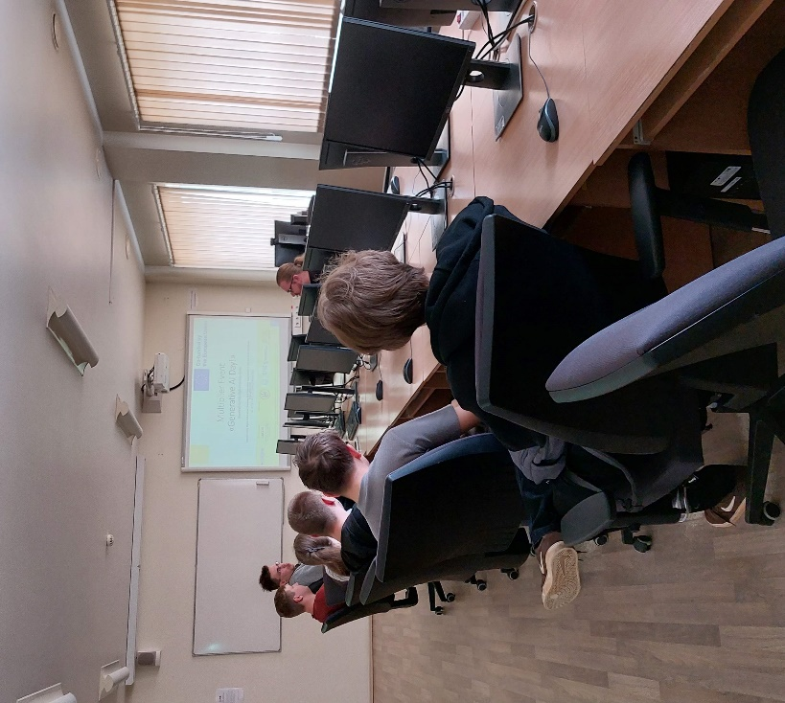
Multiplier Event Evaluation Survey

Thank you for attending our DialogEduShift event. Your feedback is crucial in helping us improve future events. Please take a moment to respond to the following statements by selecting the answer that best reflects your experience.

 | Strongly Disagree | Disagree | Neutral | Agree | Strongly Agree
 | 1 | 2 | 3 | 4 | 5
- The event met my expectations in terms of content and delivery |  | 2 | 4 | 14 | 22
- The speakers and facilitators were knowledgeable and engaging. |  | 1 | 5 | 7 | 29
- The topics covered in the event were relevant to my professional or personal interests. |  | 1 | 4 | 9 | 28
- I feel more informed about the topics and themes of the DialogEduShift project after attending the event. |  | 1 | 5 | 6 | 30
- The event provided valuable networking opportunities with other participants. |  | 2 | 3 | 6 | 31
- I would recommend the DialogEduShift resources to my colleagues or peers. |  | 3 | 3 | 4 | 32

Google Links to Survey
- Germany - https://forms.gle/S5du9mqecRcy4wdx7
- Turkey - https://forms.gle/A1NcnG5paTDMjPgu8
- Ukraine - https://forms.gle/WKMyENMs9oWrNbmG9
- Latvia - https://forms.gle/JKh1Yw2bTTEbvaDX9 (We used the form in Latvian https://forms.gle/qRFEvGyUtareGrKw7)
- Poland - https://forms.gle/VTHeqtBttG56MbxC7

